ELECTRO-FISHING

1.1 Electro-fishing by wading.

Safari Research 550d backpack
24volts
Powered by 2x12 volt batteries
A smooth DC current is used when fishing.

The Fishing probes are triangular in shape 42cm at base rising to 42 cm at the apex.
They are covered in a 5-8mm “fryma” 5mm mesh.
The landing nets used to catch the fish are “ D “ shaped 40cm at base and 38cm in width. The mesh used is “fryma” or “golf” 5mm.

Stop nets used are generally 5mm 210/18 knot less nylon. The widths and lengths of the stop nets vary according to river size.

IG600 Front Pack

It consists of 24V battery (2 x 12v 7.5Ah batteries) a front control box with an anode and cathode.
The Fishing probes are circular in shape ranging in sizes 20, 30 or 40cm.There is no net attached to this circular ring. Fish are caught by a small hand net held by the fisher or another person in the river.
Settings depend on size of fish, depth of water, conductivity.
Pulse or DC: Battery life v welfare
Frequency:40pps for salmonoids etc
Voltage: 220volts - 560volts
Pulse width: 4 – 6 mS good results.

See below the settings guide lines for operation of the IG600.

Surveys
For normal stock assessments, three catch depletions (removal method) are fished with the fish being removed after each pass. The method is described in Hedger et al. (2013).
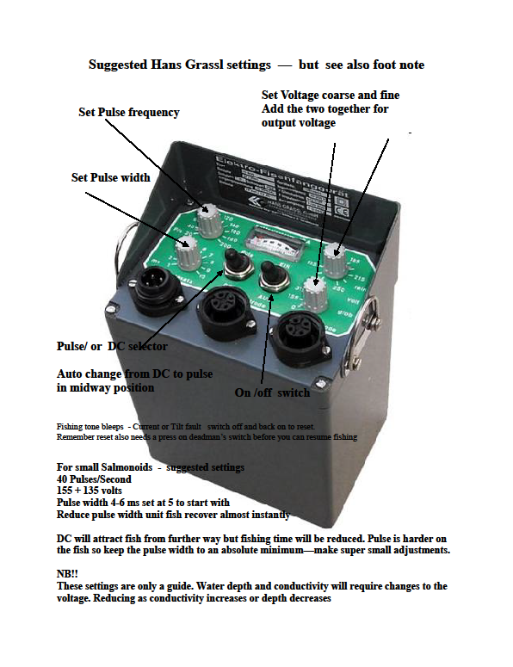

SEINING

2.1 BEACH SEINING

The net is 60m long*3m deep with a built in bulge. The mesh is 9mm half mesh 210/24 knot less nylon. The top rope is 10mm with 10mm floats attached every metre. The bottom rope is 10mm with half kg lead weight attached per half meter.

The net is 80m long*3m deep. The mesh is 18mm 210/48 knot less nylon. The top rope is 10mm “dynaflex” with 10mm floats attached every 75 cm. A 12.5mm orange float is attached at the middle. The bottom rope is 10mm “dynaflex” with 0.5kg lead weight attached every meter. The holding bag of the net is 2.5m in height* 2m wide * 2m long.

TRAPPING

6.2 FYKE NETS

The Fyke net consists of two traps facing each other, joined by a leader net, 8m long and mesh size 16mm. Cork floats are attached every 70cm on the top line and lead shots are attached every 16cm on the bottom line. Each trap consists of two chambers and a cod end with knot to knot mesh sizes of 16,12,and 10mm respectively. The trap entrance consists of a metal ring 55cm in diameter with six rings of diminishing diameters (50,45,40,35,30,and 30cm) evenly spaced through the chamber to trap exit. Ten of these nets are attached together when fishing.

The protocol is laid out in the National Eel monitoring programme and for Burrishoole as described in Poole (1994).

6.4 TRAPS

There are six fixed trapping facilities on waterways in Ireland. Out of the six systems five have partial trapping with full trapping in operation on the Burrishoole system since 1970.

The traps at Burrishoole. See separate Operations manual.

Upstream and downstream Wolf-type fish traps are situated on two short rivers which join L. Feeagh to the tidal L. Furnace, the Mill Race and the Salmon Leap.
The Mill Race trap consists of a fish fence 3.5 feet high placed at an acute angle across the channel. An upstream trap is built on the right bank at the upstream end of this fence. A conventional wooden inscale arrangement prevents fish escaping downstream once they have entered the upstream fish trap. Gratings of vertical bars spaced 25mm apart similarly prevent the fish from escaping upstream from the trap. The trap is fitted with a false floor unit consisting of wooden battens spaced 12mm" apart laid on a prefabricated metal subframe. The whole unit can be raised and lowered as required.
The downstream end at the left bank a channel leads in to a smolt trap (Wolff Trap) with slopping wooden battens 12mm apart in which all fish moving downstream can be trapped.
The Salmon Leap trapping system incorporates a sluice gate arrangement which controls the level of water going through. The sump is covered over with a grid flush with the general bed of the channel surrounding it preventing the escape of any fish downstream through it.
On the downstream side of the weir crest a Wolf trap incorporates sloping wooden grids with 12mm spacings leading fish into a flume at the downstream end. This flume discharges into a tank inside the smolt house which is recessed into the right bank immediately below the installation. Adjoining the left bank a Denil type fish pass has been constructed leading fish from below this installation to an adult upstream fish trap of similar construction to the Mill Race trap.

